Name:...........................................
Class:...........................................

Mathematics for Engineering
Exercise Book

Trần Trọng Huỳnh - 2018

CALCULUS
Chapter 1: Function and Limit
1. Find the domain of each function:
a. b.
c. d.
2. Find the range of each function:
a. b. c.
3. Determine whether is even, odd, or neither
4. Explain how the following graphs are obtained from the graph of f(x)
a. b. c. d.
5. Suppose that the graph of is given. Describe how the graph of the function can be obtained from the graph of .
6. Let and . Find each function
a. b. c. d.
7. Let . Find
a. b.
8. Use the table to evaluate each expression
a. f(g(1)) b. g(f(1)) c. f(f(1)) d. g(g(1))
e. f.
x | 1 | 2 | 3 | 4 | 5 | 6
f(x) | 3 | 1 | 4 | 2 | 2 | 5
g(x) | 6 | 3 | 2 | 1 | 2 | 3

9. Evaluate the following limits
a. b. c. d.
e. f. g. h.
a-e ; b-g ; c-f ; d-h
10. Determine whether each curve is the graph of a function of x. If it is, state the domain and range of the function.

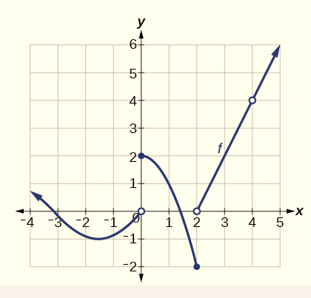
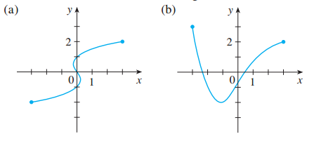
11. The graph of f is given.
a. Find each limit, or explain why it does not exist.
i. , and
ii. and
b. At what numbers is discontinuous?
12. Determine where the function is continuous
a. b. c.
13. Find the constant m that makes f continuous on its domain
a. b.
c. d.
14. Find the numbers at which the function is discontinuous.
Chapter 2: Derivatives
1. Find an equation of the tangent line to the curve at the given point:
a. b.
c. d.
2. Find
a. b. c.
d. e. f.
3. Find
a. b. c.
4. Find for:
a. and b. and
c. and d. and
5. Find for: dy = y’(x)dx
a. b. c. , and
6. The graph of is given. State the numbers at which is not differentiable
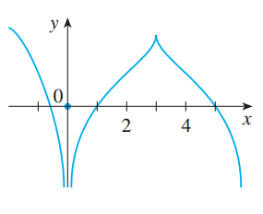
a. b.
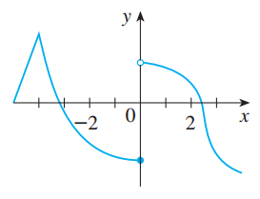

7. A table of values for is given
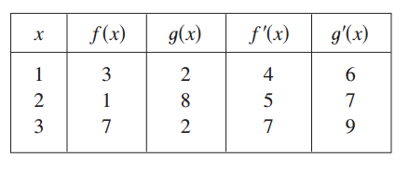
a. If , find b. If , find
c. If , find d. If , find
8. If , where , find .
9. For the circle .
a. Find
b. Find an equation of the tangent to the circle at the point (3, 4).
10. Let
a. Find
b. Find an equation of tangent to the curve (L) at the point (3, 3)
11. Find y' by implicit differentiation
a. b. c.
12. Find in terms of
a. b.
13. Each side of a square is increasing at a rate of 6 cm/s. At what rate is the area of the square increasing when the area of the square is 16 cm² ?
14. If and , find when y = 4 and x > 0.
15. If , find when
16. Find the linearization L(x) of the function at a.
a. b.
17. The equation of motion is for a particle, where s is in meters and t is in seconds. Find the acceleration (in m/s²) after 3 seconds.

Chapter 3: Applications of Differentiation
1. Find the absolute maximum and absolute minimum values of the function on the given interval
a. b.
c. d.
2. Find the critical numbers of the function
a. b. c.
3. Find all numbers that satisfy the conclusion of the Rolle's Theorem
a. b.
4. Find all numbers that satisfy the conclusion of the Mean Value Theorem
a. b.
5. If and , how small can possibly be?
6. Find where the function is increasing and where it is decreasing.
7. Find the inflection points for the function
a. b. c.
8. Find for and .
9. Find the point on the parabola that is closest to the point
10. Find two numbers whose difference is 100 and whose product is a minimum.
11. Find two positive numbers whose product is 100 and whose sum is a minimum.
12. Use Newton’s method with the specified initial approximation to find
a. b.
c. d.
13. Find the most general anti-derivative of the function.
a. b.
c. d.
14. Find the anti-derivative of that satisfies the given condition
a. b.
15. A particle is moving with the given data. Find the position of the particle
a.
b.
c.
16. The figure shows the graph of the derivative of a function
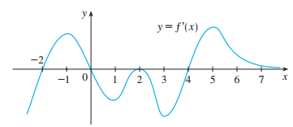
a. On what intervals is increasing or decreasing?
b. For what values of x does f have a local maximum or minimum?

Chapter 4 - 6: Integration
1. Estimate the area under the graph of using 6 rectangles and left endpoints
a. , b. ,
c. A table of values for f is given
x | 1 | 2 | 3 | 4 | 5 | 6 | 7
f(x) | 5 | 6 | 3 | 2 | 7 | 1 | 2
3. Repeat part (1) using right endpoints
4. For the function . Estimate the area under the graph of using four approximating rectangles and taking the sample points to be
a. Right endpoints
b. Left endpoints
c. Midpoints
5. Use (a) the Trapezoidal Rule, (b) the Midpoint Rule, and (c) Simpson’s Rule to approximate the given integral with the specified value of n.
a. b.
6. Let . Find the approximations , ,, and for .
7. Find the derivative of the function
8. Find
a. b.
c. d.
9. Find the average value of the function on the given interval
a. b.
c. d.
10. A particle moves along a line so that its velocity at time t is v(t) = t² – t – 6 (m/s)
a. Find the displacement of the particle during the time period 1 ≤ t ≤ 4
b. Find the distance traveled during this time period
11. Suppose the acceleration function and initial velocity are a(t)= t + 3 (m/s²), v(0)=5 (m/s). Find the velocity at time t and the distance traveled when 0 ≤ t ≤ 5.
12. A particle moves along a line with velocity function , where is measured in meters per second. Find the displacement and the distance traveled by the particle during the time interval .
13. Evaluate the integral
a. b. c.
d. e. f.
a-b, d-f
14. Evaluate the integral
a. b. c.
d. e. f.
14b-13c, 14f-13e
15. Suppose f(x) is differentiable, f(1) = 4 and . Find
16. Suppose f(x) is differentiable, f(1) = 3, f(3) = 1 and . What is the average value of f on the interval [1,3]?
17. Let . Evaluate
18. Find for
a. b.
19. Determine whether each integral is convergent or divergent. Evaluate those that are convergent.
a. b. c. d.
e. f. g.

i. j. k. l.
20. Use the Comparison Theorem to determine whether the integral is convergent
or divergent
a. b. c.
d. e. f.
LINEAR ALGEBRA
Chapter 1: Systems of Linear Equations
1. Write the augmented matrix for each of the following systems of linear equations and then solve them.
a. b.
c. d.
2. Compute the rank of each of the following matrices.
a. b.
c. d.
3. Find all values of k for which the system has nontrivial solutions and determine all solutions in each case.
a. (1) b.
c. d.
4. Determine the values of m such that the system of linear equations has exactly one solution.
a. (1) b.
c. d.
5. Determine the values of m such that the system of linear equations is inconsistent.
a. b. (1)
6. Find a, b and c so that the system has the solution
7. Consider the matrix
a. If is the augmented matrix of a system of linear equations, determine the number of equations and the number of variables.
b. If is the augmented matrix of a system of linear equations, find the value(s) of k such that the system is consistent.
8. Find all values of k so that the system of equations has no solution.
a. b.
9. Find all values of a and b for which the system of equations
is inconsistent.
10. Solve the system of linear equation corresponding to the given augmented matrix
a. b.
11. Determine the values of m such that the rank of the matrix is 2
a. b. c.
12. Solve the system

Chapter 2: Matrix Algebra
1. Let and . Compute the matrix
a. b. c. d.
e. f. g. h.
2. Suppose that A and B are nxn matrices. Simplify the expression
a.
b.
3. Let and .
a. Compute
b. Compute if
4. Find the inverse of each of the following matrices.
a. b. c. d.
5. Given . Find a matrix X such that
a. b. c.
6. Find when
a. b. c.

7. Write the system of linear equations in matrix form and then solve them.
a. b. c.
8. Find if
a. b. c.
9. Solve for X
a. b. c.
(where A, B and C are nxn invertible matrices)
10. Compute
11. Let be a linear transformation, and assume that and
a. Compute b. Compute
c. Find the matrix of T d. Compute
12. Let be a linear transformation such that the matrix of is.
Find
13. The (2;1)-entry of the product
Chapter 3: Determinants and Diagonalization sự chéo hóa
1. Evaluate the determinant
a. b. c. d.
e. f.
2. Find the minors and the cofactors of the matrix
a. b. c.
3. Find the adjugate and the inverse of the matrix
4. Let . Find
a. b.
c. d.
e.
f.
5. Let A and B be square matrices of order 4 such that and . Find
a. b.
c. d.
6. Find all values of m,k for which the matrix is not invertible
a. b. c.
7. Find the characteristic polynomial of the matrix
a. b.
c. d.
8. Find the eigenvalues and corresponding eigenvectors of the matrix
a. b.
c. d.
9. Find the determinant of the matrix
10. Find the (1, 2)-cofactor and (3,1) - cofactor of the matrix
11. Let . For which values of x is invertible ?
Chapter 5: The Vector Space
1. Let and in .
Find scalars a, b and c such that
2. Write v as a linear combination of u and w, if possible, where
a. b. c. d.
3. Determine whether the set S is linearly independent or linearly dependent in corresponding vector spaces.
a. b.
c. d.
e.
4. For which values of k is each set linearly independent in corresponding vector spaces.
a. b.
c. d.
5. Find all values of m such that the set S is a basis of
a. b.
6. Find a basis for and the dimension of the subspace U
a. b.
c. d.
e. f.
g. h.
7. Find a basis for and the dimension of the solution space of the homogeneous system of linear equations.
a. b. c.
8. Find all values of m for which x lies in the subspace spanned by S
a. and
b. and
c. and
d. and
9. Find the dimension of the subspace
10. Let . Find and
11. Which of the following are subspaces of R³ ?
12. Let and . Compute
13. Let such that and . Find
a. b.

Chapter 4: Vector Geometry
4.1.Vectors and Lines
Bài tập 4.1.2, 4.1.3, 4.1.4, 4.1.7, 4.1.10, 4.1.11, 4.1.12, 4.1.17, 4.1.18, 4.1.19, 4.1.22, 4.1.23, 4.1.24 (từ trang 222 – 225) sách Linear Algebra.
4.2 Projections and Planes
Bài tập 4.2.1, 4.2.2, 4.2.3, 4.2.4, 4.2.10, 4.2.11, 4.2.12, 4.2.13, 4.2.14, 4.2.15, 4.2.16, 4.2.19, 4.2.20, 4.2.21, 4.2.32 (từ trang 239 – 244) sách Linear Algebra.
4.3 More on Cross Product
Bài tập 4.3.3, 4.3.4, 4.3.5 (từ trang 248 – 249) sách Linear Algebra.

